**Basics of HTML**

By Harsh R Jain – 1BG17CS031

# Introduction to HTML

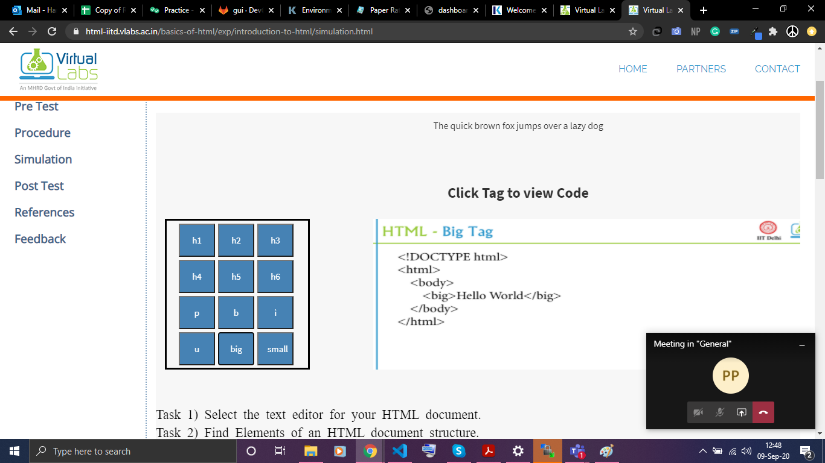

# Understanding Headers

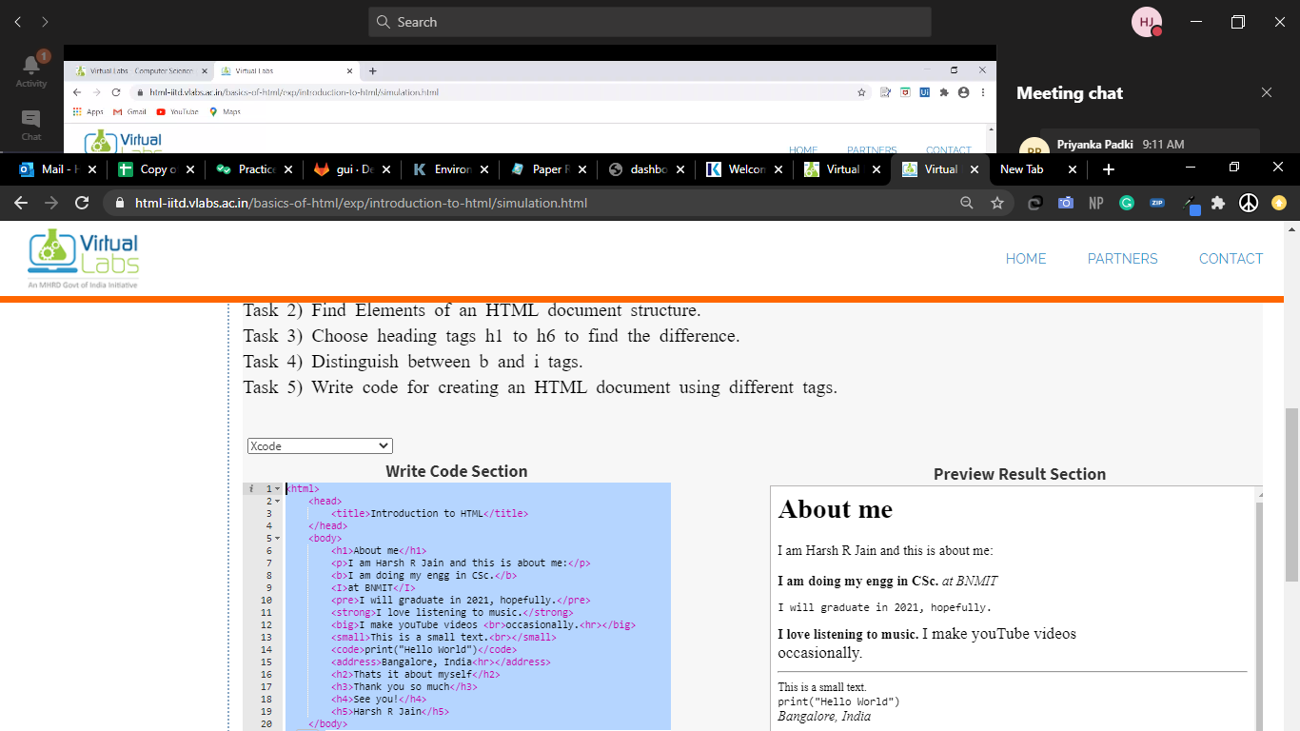

# [Applying Attributes in HTML Tags](http://html-iitd.vlabs.ac.in/basics-of-html/exp/html-tags)

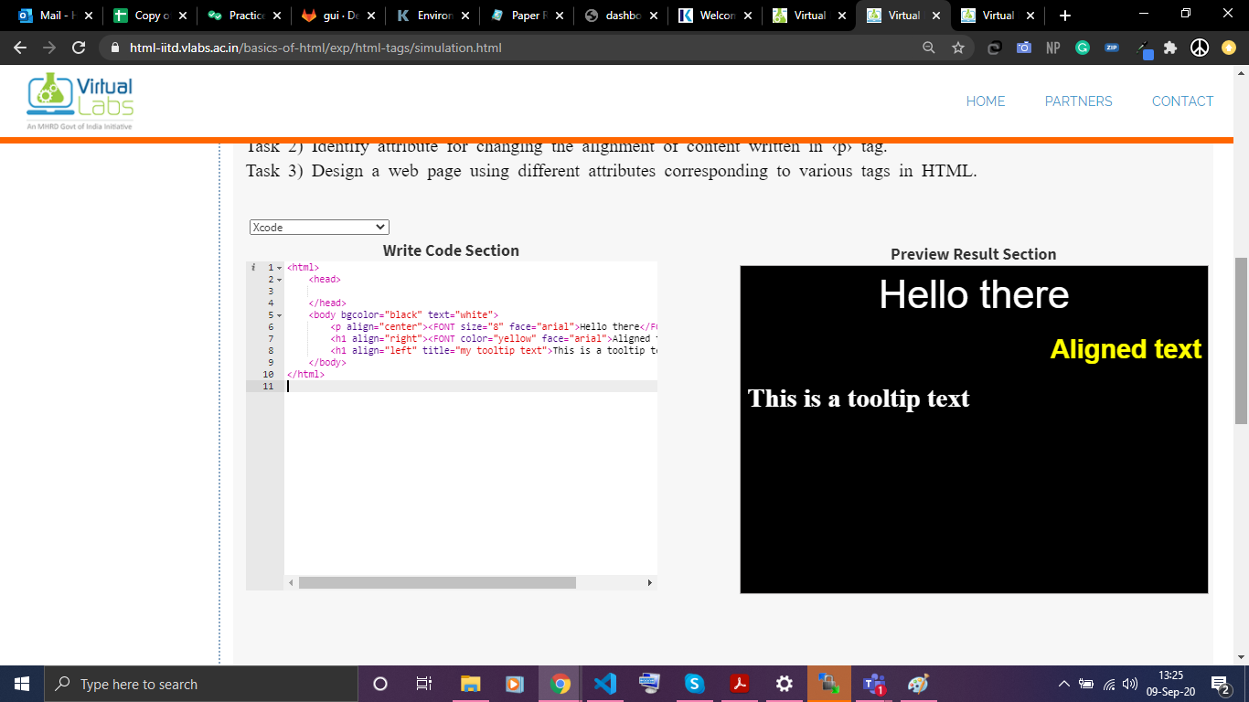

# [Inserting images through img tags](http://html-iitd.vlabs.ac.in/basics-of-html/exp/img-tags-in-html)

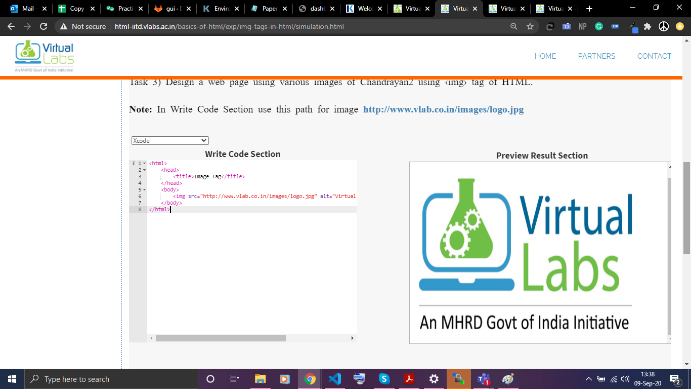

# [Types of Lists in HTML](http://html-iitd.vlabs.ac.in/basics-of-html/exp/lists-in-html)

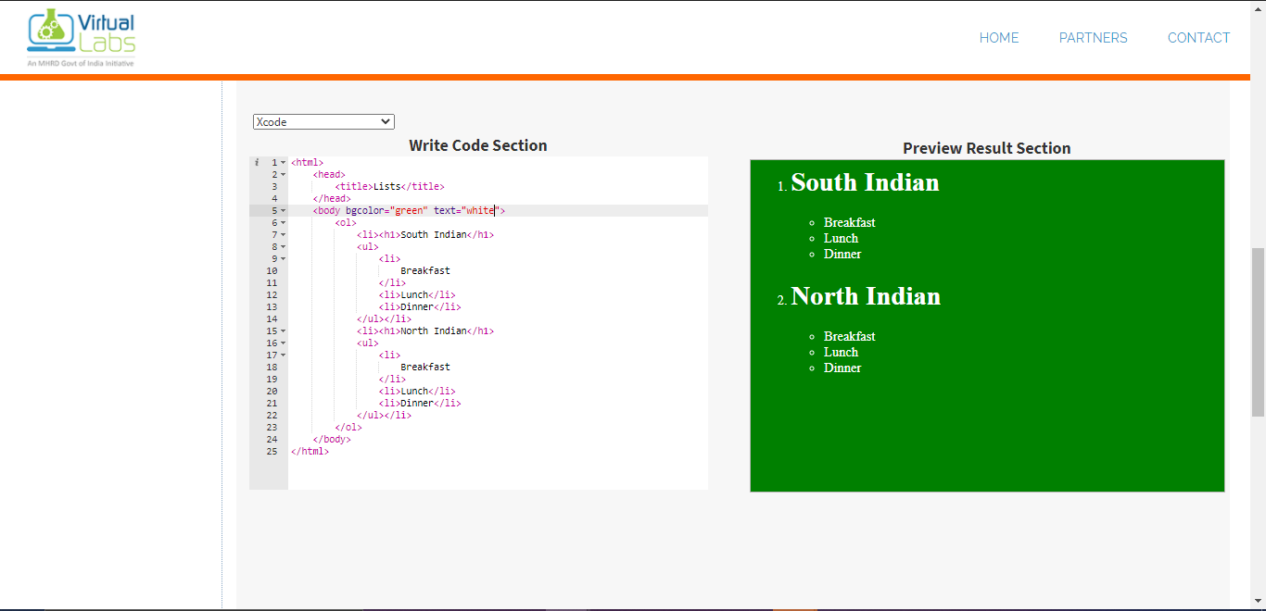

**FIN**